1 a) Sketch the shape of the magnetic field around the magnet. (1)
b) Show the direction of the magnetic field. Indicate on the diagram where the magnetic field is strong and where it is weak. (3)

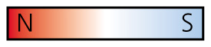

2 Sandra is attempting to become the first woman to walk from Greenland to the geographical North Pole. Explain why she should not rely on her compass alone. (2)

3 What is the difference between a permanent magnet and an induced magnet? (2)

4 Magnetic force is a non-contact force. Which of the following is also a non-contact force?
gravity friction air resistance (1)
5 A solenoid is a long coil of wire through which a current is flowing.
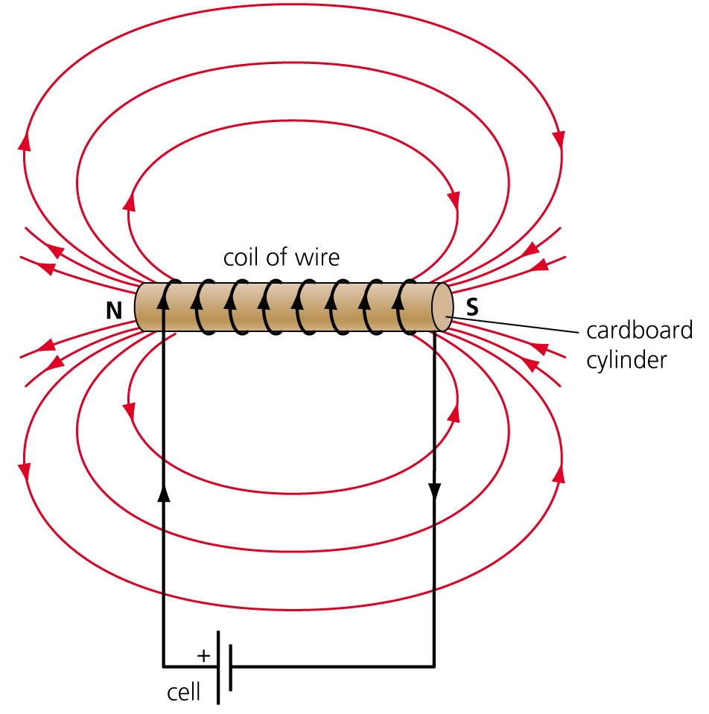
Are the following statements about the solenoid true or false?
a) Increasing the number of turns in the coil increases the magnetic field strength.

b) Putting a steel core in the centre of the solenoid decreases the magnetic field strength.

c) The magnetic field strength increases if the current increases. (3)

6 The diagram shows two pairs of magnets.
a) Which pair of magnets has the higher magnetic flux density? A or B? (1)

b) A wire of length L that is carrying a current I is placed between the magnets.
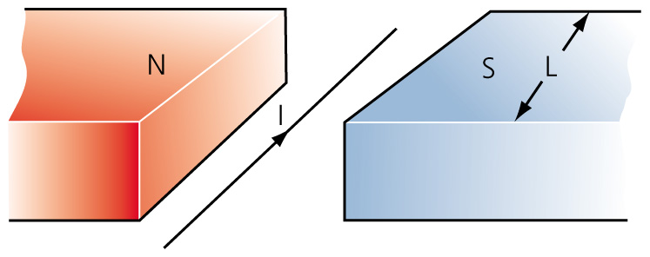
The wire experiences a force F, where F = BIL and B is a measure of the magnetic flux density (measured in tesla T).
i) What is the unit of force? (1)

ii) The force on the wire is at an angle of ………………. in relation to the magnetic field. (1)
iii) If the force on the wire is 0.1 N, the current is 3.0 A and the length of wire between the magnets is 0.15 m, calculate the magnetic flux density. (2)

7 Fleming’s left-hand rule helps to determine the direction of movement in a magnetic field. At what angle will the direction of the magnetic field and the direction of the current be to each other? (1)

8 a) An induced potential difference can be produced across the ends of the wire if the wire is moved through a magnetic field. If the wire is part of a complete circuit, what type of current will be flowing? (1)

b) Inducing a current in this way is called the ………………. effect. (1)
c) What happens to the current if the direction of movement is reversed from up to down? (1)

d) What happens to the current if the strength of the magnets is increased? (1)

9 The diagram shows an electrical component.
a) Identify the component. (2)

b) Describe how the component named in 9 (a) works. (3)

c) Electricity transmitted through the National Grid network is distributed at 400 000 V.
What is the name given to the component that is used at a local level to reduce the
voltage to 240 V? (2)

d) For a transformer:
power supplied to the primary coil = power provided by the secondary coil
V_{p} × I_{p} = V_{s} × I_{s}
where I_{p} is the current in the primary coil
I_{s} is the current in the secondary coil
V_{p} is the p.d. across the primary coil
V_{s} is the p.d. across the secondary coil.
where V_{p} is the p.d. across the primary coil
V_{s} is the p.d. across the secondary coil and
n_{p} is the number of turns in the primary coil
n_{s} is the number of turns in the secondary coil.
Using the information above, fill in the gaps in the table.
Primary turns | Secondary turns | Primary p.d. (V) | Secondary p.d. (V) | Step up/step down
200 | 40 |  | 6
400 | 10 000 | 20
 | 500 | 24 | 12
(6)
e) Explain why very high voltages are used to transmit electrical power over long distances. (2)

10 The diagram shows a simple transformer used to light a 12 V lamp. The lamp shines dimly when the ac input is 120 V.
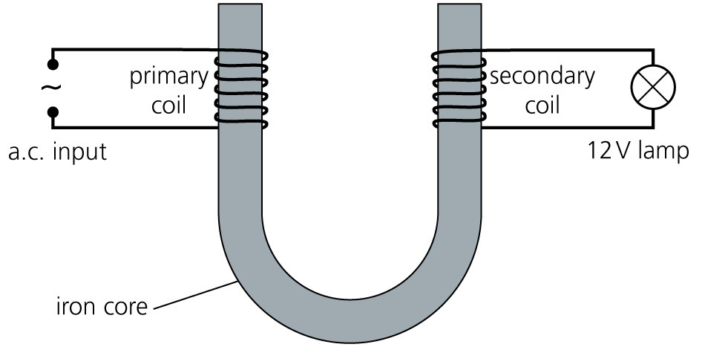
a) Explain what happens to the brightness of the lamp when the a.c. power is replaced
with d.c. power. (2)

b) If the potential difference of the a.c. supply is increased, what happens to the lamp? (1)

11 A wind-up radio does not need a battery to operate it. This is good for the planet. A wind-up kettle could reduce the electricity being used in a house. Explain why such a kettle does not
exist. (2)

TOTAL = 42

1 a) Shape of field drawn in figure below. (1)
b) 1 mark for each of direction, strong and weak areas. (3)
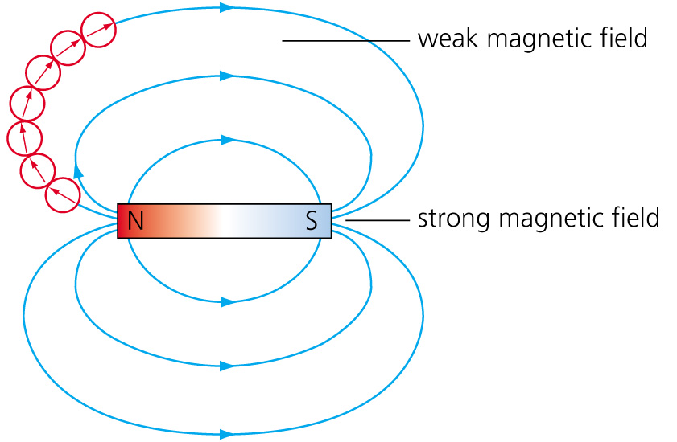
2 The magnetic north pole is some distance from the geographic North Pole. Clearly, if she followed her compass she would end up at the wrong place. The compass points to magnetic north. (2)
3 A permanent magnet has permanent north and south magnetic poles. The induced magnet has temporary magnetic poles and is only magnetic when the field is induced. (2)
4 Gravity (1)
5 a) True
b) False
c) True (3)
6 a) B (1)
b) i) N (1)
ii) 90° (1)
iii) F = BIL; B = = = 0.22 tesla (2)
7 90°/ right angle (1)
8 a) Induced (1)
b) Motor effect (1)
c) It reverses. (1)
d) It increases. (1)
9 a) Step up transformer (2)
b) An alternating current supplied to one coil produces a changing magnetic field. The iron core becomes magnetised. An alternating potential difference is induced in the secondary coil. (3)
c) Step down transformer (2)

d)
Primary turns | Secondary turns | Primary PD (V) | Secondary PD (V) | Step up/step down
200 | 40 | 30 | 6 | down
400 | 10 000 | 20 | 500 | up
1000 | 500 | 24 | 12 | down
(6)
e) To transmit the same amount of power, a lower current is required. Less energy is lost as heat with a lower current, so it is more efficient to transmit at a high voltage. (2)
10 a) The lamp goes out. You cannot use d.c. power as no current would be induced in secondary coil. The transformer only works on a.c. power. (2)
b) The brightness of the lamp increases. (1)
11 A kettle needs a lot of power to bring water to boiling point. It is practically too difficult to achieve this with a winding device. It works for a radio because the radio needs much less power to operate. (2)
TOTAL = 42

